**Kubernetes GitOps: A Beginner's Guide with a Hands-On Tutorial**

## Simple GitOps Workflow

GitOps basically works on the principle of making Git the source of truth, including moving everything to code and storing and maintaining everything in Git. When it comes to deployment, make use of an operator to deploy what is configured in Git and Yaml in a declarative fashion. Since all the developers are primarily friendly with Git, GitOps simplifies their complex workflow.

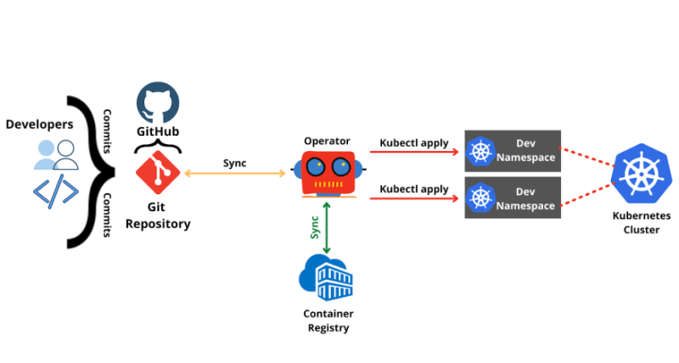

## Prerequisites

* In this tutorial, we will use a continuous delivery tool such as Harness to do GitOps. Hence, create a free [Harness account](https://app.harness.io/auth/#/signup/?module=cd&utm_source=internal&utm_medium=social&utm_campaign=devadvocacy&utm_content=pavan_gitops_article&utm_term=get-started). It uses Argo CD-as-a-Service.

I created Harness account and log in with google

* GitHub account and a sample repo to experiment with. I have a [sample repo](https://github.com/pavanbelagatti/argocd-example-apps) you can fork it and use.

I cloned this repo and put it in my GitHub account

I set up the GitOps pipeline, I choose **Kubernetes with GitOps** and installed agent successfully.After that I choose git and use my own source and make succesfull authentication. I select Target revision as 'master' and Path as 'helm-guestbook'. After that I select 'Harness Hosted' to test the GitOps workflow and Connect to Cluster button and make sure the connection is successful.

After that I click on 'Create and Sync Application'.

I check each tab starting from the 'Resource View'

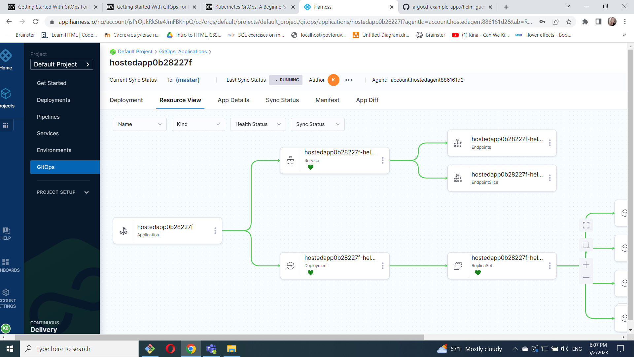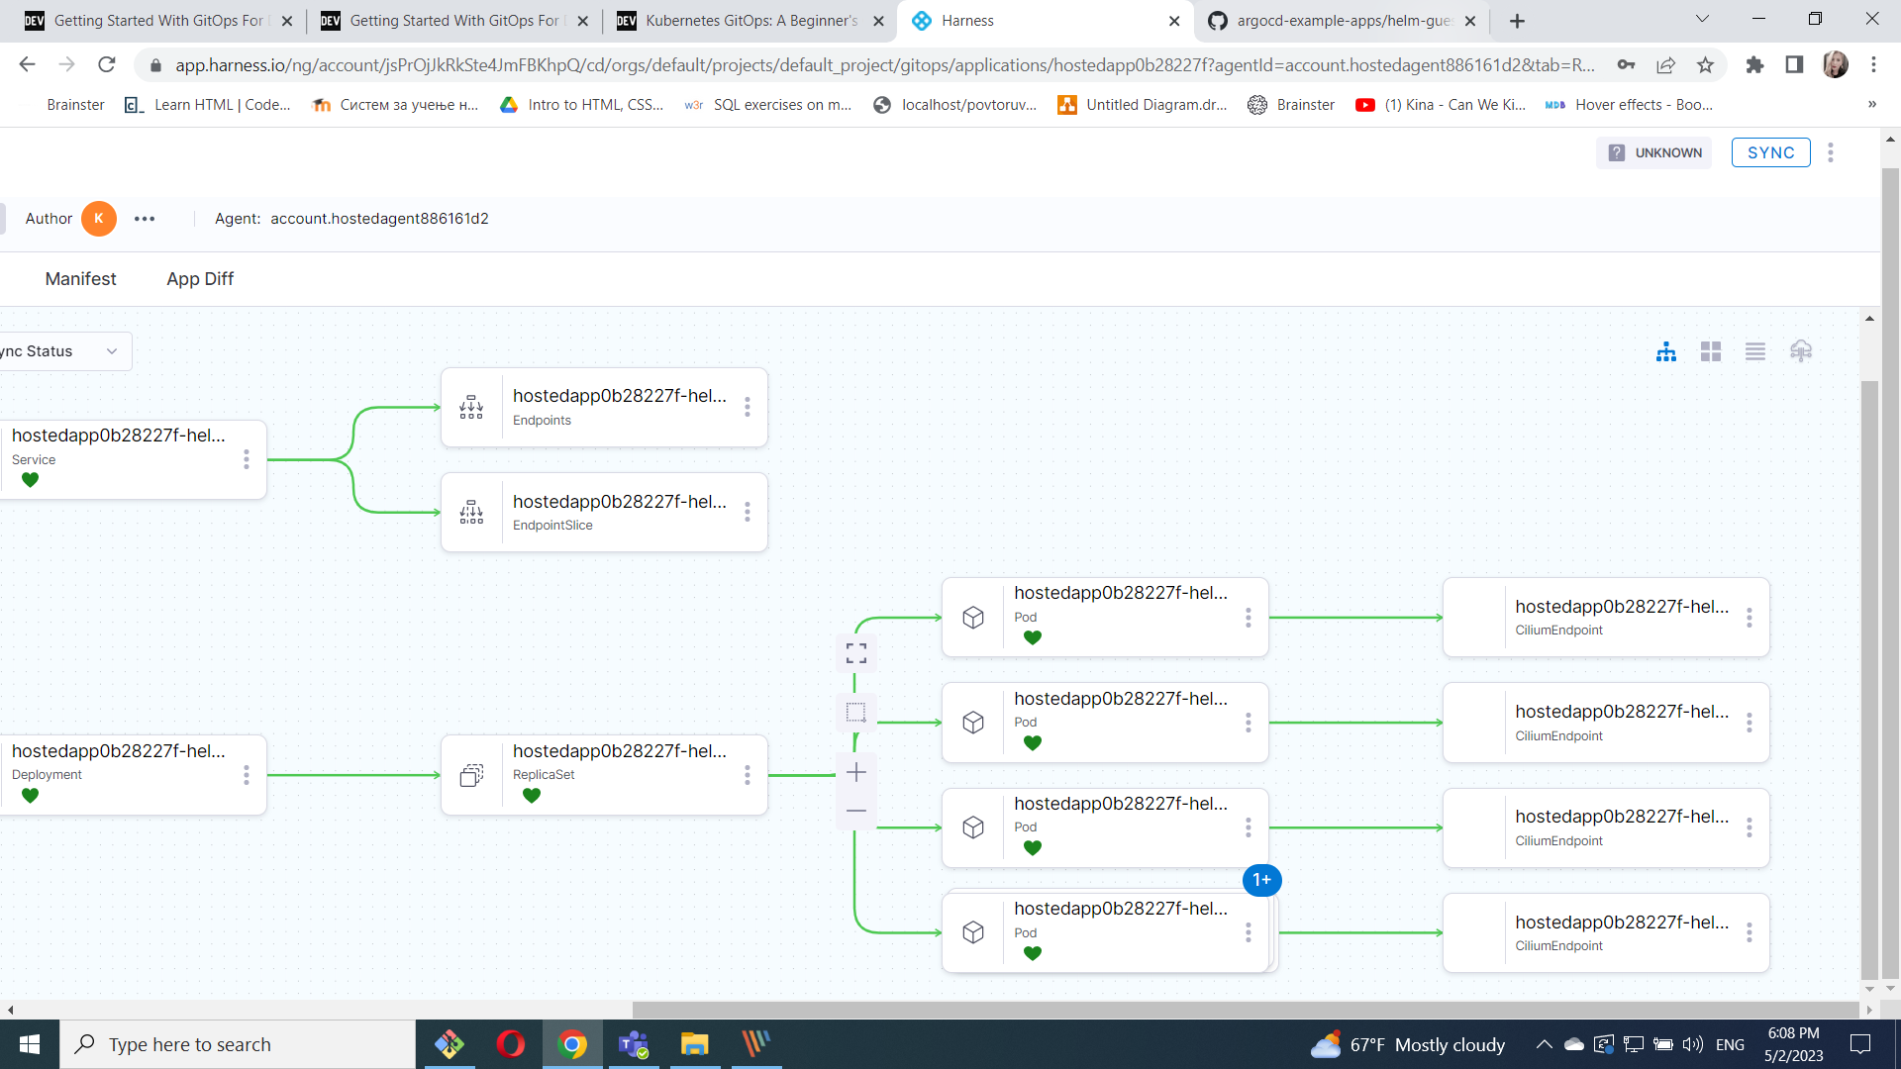

I changed sync policy, from 'manual', to 'automated'.

I see 4 replicas running as mentioned in our values.yaml file.

I changed to 7 and get this

